Website research - Dauphine’s Revival

Idea: After listen to the first song on the list, I wanted to design a website that reflected the night life on the streets of New York or any major city. I started my search with scenery picture of city streets that morphed into neon nostalgia. The idea is display the life of traditional jazz in a more modern setting. The color theme of the website is a dark purple -blue, gold orange, and faded red. The audience that I’m aiming for is traditional jazz listeners and younger audiences who’s look for music that nostalgic.

* Home Page: The home page will be the place where the band post updates on tours, song release, and album drops. Above these post in the header, a gallery of picture of the reason tour or performances will be displayed around the logo of the band.
* About page: In this page it will go over the mission statement of the band. From there, the page will individual dive into the members of the band. Next to these profiles of the band members will be picture of the member on stage or in practice.
* Music Page: On this page will hold the recent albums will tracks and song length. The album art will be on the right next to a album description or review.
* Tour page: For the layout of this page I will basic is on the Broadway website where tours are divided into three columns. I will also have three extra tabs for state, date, threat/hall. These three tab will make it easier for user to lookup tours for the band.

Home page:

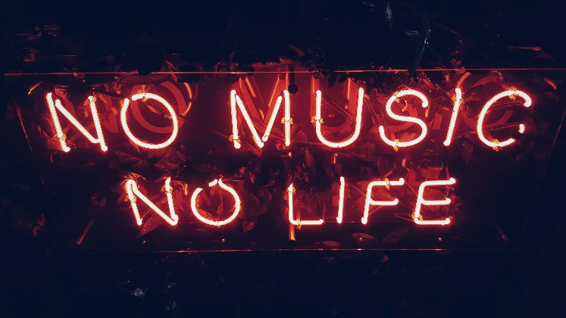(head)

 Logo

Art gallery

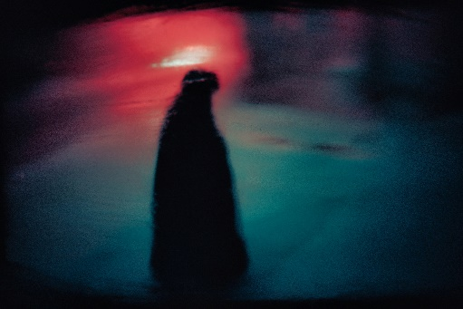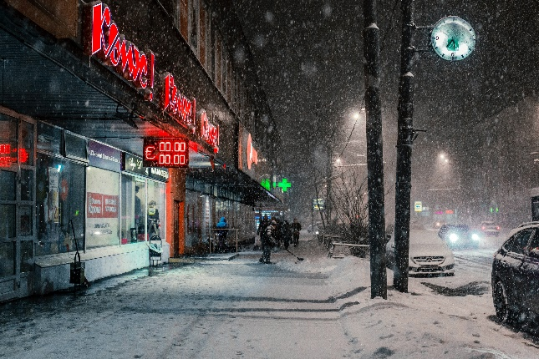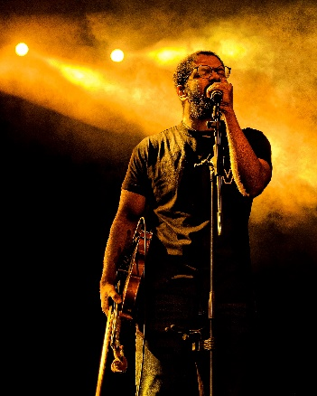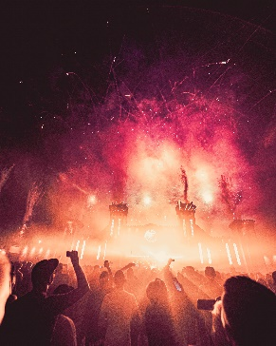

About:

Gives an overview of the band. Should include the kind of music the band plays, who is in the band, how it was formed, and other relevant information.

<http://www.turkuazband.com/band>

Balancing male-female harmonies, strutting guitars, wild horn arrangements, and interminable grooves, a spirit takes shape on stage nightly for Turkuaz via larger-than-life performances. Among numerous critical plaudits, *The New Yorker* claimed, *“[Turkuaz] delivers horn-filled funk incorporating elements of R&B, psychedelic pop, gospel, Afro-pop, New Wave, classic rock, and just about any genre that gets people dancing*.*”*

*Musician:*

1. Founded by guitarist Marcelo Pereira and lead by singer/guitarist Tiago Masseti, the group have performed alongside some of the leading names in Progressive Music, like Periphery, Symphony X, Devin Townsend, Pain of Salvation, King’s X and many others.

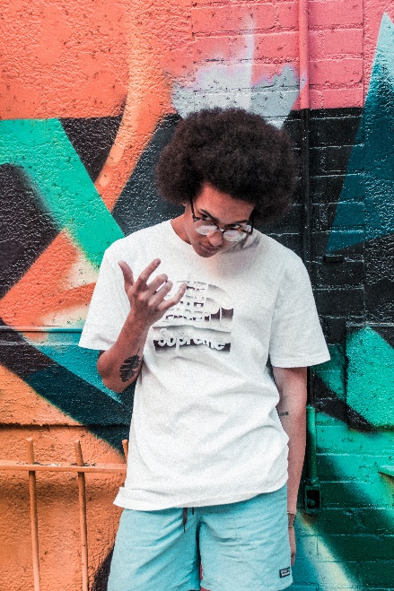 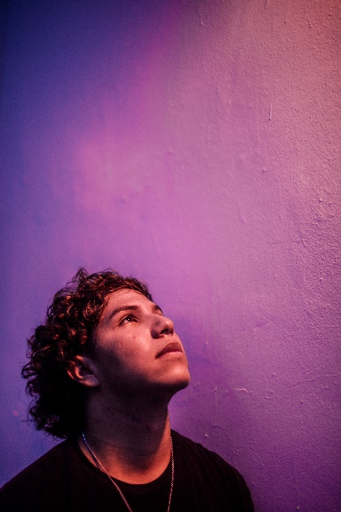

1. Before joining the group, Juno Nominated was an artist who performed on four of the seven continents. Wearing several hats as writer, composer, producer, creative director and promoter, Chelsea successfully hand selects other talented artists in Toronto to be her opening acts for her own annual live music series ‘An Intimate Evening with Chelsea Stewart’.

From Rototom Sunsplash in Europe, to Reggae Sumfest in Jamaica, to arenas in South Africa, Chelsea is continuously making moves and making people move with her style of reggae music worldwide. Just coming off of her first African tour, Chelsea has been melting hearts country to country with her sweet lollipop voice laced with enough sugar to help make the bitterness of life's struggles a bit sweeter.



1. Law's interest in music began when she was 8 years old by playing the electronic keyboard. As a 10 year old she was trained as a classical pianist where she achieved Grade 5 & also Grade 5 Music Theory. At the age of around 12 Law started to learn electric guitar  
     
   At the age of 15 Law began to compose and record her own material and has developed her own technical abilities.
2. 

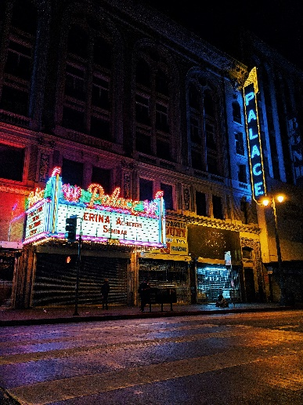 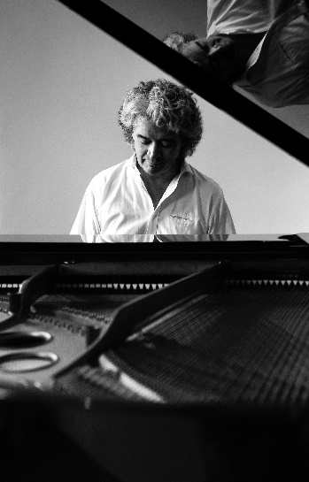 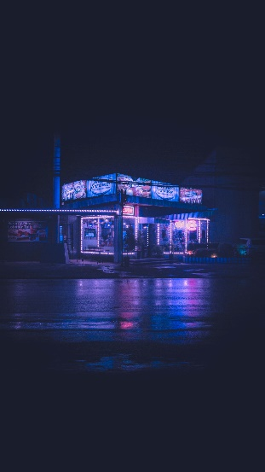

Music:

This pages shows the band’s discography. Include at least 4 albums on this page with the album art, release year, and track list for each album.

* Lake Minnetonka – Melbourneapolis feb 2, 2018 February

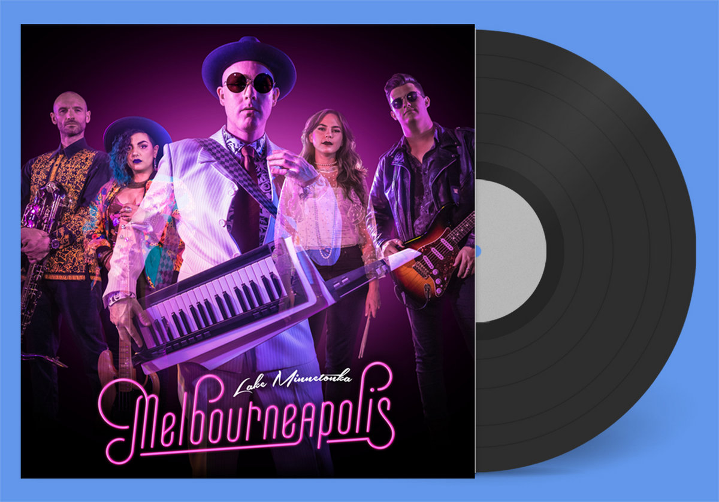

* Philly Cheese String
* Clipnosis
* There it is
* Termac
* August
* Enamoured Moon Run Out
* Out There Bout There
* Am Buner Funk
* Rare Love
* The Miracle Kind
* Lex One and Lucian White – Midnight Crisis: Feb 19 2018

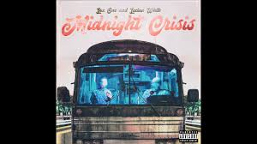

Track:

* Midnight Crisis (feat. Black Violin and Mr MFN eXquire){5:08}
* Get Right {3:41}
* Don’t Call Me Sweetie {3:02}
* Just My Type {3:28}
* 16 Musgrove {1:59}
* Consistency {3:02}
* Ruby Lane {4:35}
* Contra Mantra {2:32}
* Do it {2:37}
* I’m Good {4:07}
* PenHouse {3:56}
* Starlight Groove {3:51}
* Homecoming {4:19}
* First Time {3:14}
* So Far Away {3:17}
* Night Tremors (iris){2:41}
* Beautiful Depression {4:24}
* Turkuaz – Life In The City: sept 28 2018



**Turkuaz** has seen itself on our [Best of Funk](https://funkatopia.com/funk-music-reviews/20-best-funk-albums-of-2015/) list before in 2015 with their album **Digitonium** which also garnered [a review](https://funkatopia.com/funk-music-reviews/review-turkuaz-digitonium/) in the process. **Mr. Christopher** also did an [interview with **Dave Brandwein** of **Turkuaz**](https://funkatopia.com/funk-news/interview-dave-brandwein-of-turkuaz/) regarding the release of this album to dig a bit deeper.

**Turkuaz** has always delivered a bit of quirkiness to their releases and **Life In the City** is no different. The main difference is that **Life In the City** seems less thematic and more focused on maintaining the music styling and keeping the continuity. It’s not only rooted in funk, but has extra layers that flesh everything out and make the songs more full and thick and ambient, which has proven to be their calling card.

* Review: “If I Ever Fall Asleep” blends funk-pop-rock that highlights a catchy melody and a groove that is unmistakably Turkuaz. The lyrics are creative, and the vocal harmonies and lead vocals are definitively strong. The guitar work of Brodhead is brilliant, with a warm distorted tone his leads have direction and energy.” (Griff Stevens sept 29 2018) <https://5fingerreview.com/turkuaz-life-in-the-city-review/#:~:text=%E2%80%9CIf%20I%20Ever%20Fall%20Asleep%E2%80%9D%20blends%20funk%2Dpop%2D,leads%20have%20direction%20and%20energy.>

Track:

* Life In The City {5:23}
* Superstatic {4:06}
* Make You Famous {4:57}
* The One and Lonely {4:31}
* The Question {3:59}
* If I Ever Fall Asleep {5:38}
* Lady Lovely {5:19}
* Rule The World {4:05}
* Fight the Fire {5:55}
* Trombone Shorty, backtown: April 20 2010

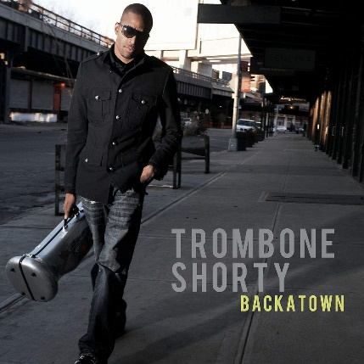

Review: “Backatown is both deeply rooted and culturally omnivorous, opening with his 'bone hard-rocking a hip-hop groove, soon joined by a brass section, rock guitar and some boozy-sounding dudes hollering shit. Shorty can also sing smooth funk, and he dubs up nasty space fusion à la 1970s Miles Davis. (Will Hermes) may 10 2010

* Hurricane Season
* On Your Way Down
* Qhiet as Kept
* Something Beautiful
* Backatown
* Right to Complain
* Neph
* Suburbia
* In the 6th
* One Night Only (The March)
* Where Y’At
* Fallin’
* The Cure
* 928
* Horn Jam

Tour: Location

AUG 1, 2020

CARAMOOR FESTIVAL

KATONAH, NY

AUG 2, 2020

LONGWOOD GARDENS OPEN AIR THEATRE

KENNETT SQUARE, PA

AUG 3, 2020

CARNEGIE LECTURE HALL

PITTSBURGH, PA

AUG 4, 2020

SIXTH & I

WASHINGTON, DC

AUG 5, 2020

SIXTH & I

WASHINGTON, DC

AUG 19, 2020

FIRST CONGREGATIONAL CHURCH

LOS ANGELES, CA

AUG 20, 2020

HERBST THEATRE

SAN FRANCISCO, CA

AUG 22, 2020

THE OLD CHURCH CONCERT HALL

PORTLAND, OR

AUG 23, 2020

THE OLD CHURCH CONCERT HALL

PORTLAND, OR

AUG 24, 2020

ST. MARKS CATHEDRAL

SEATTLE, WA

AUG 25, 2020

ST. MARKS CATHEDRAL

SEATTLE, WA

SEP 10, 2020

FOURTH PRESBYTERIAN CHURCH

CHICAGO, IL

SEP 15, 2020

BUSKIRK-CHUMLEY THEATER

BLOOMINGTON, IN

SEP 16, 2020

FOUNTAIN STREET CHURCH

GRAND RAPIDS, MI

SEP 22, 2020

MURMRR THEATRE

BROOKLYN, NY

SEP 23, 2020

MURMRR THEATRE

BROOKLYN, NY

SEP 24, 2020

UNIVERSAL PRESERVATION HALL

SARATOGA SPRINGS, NY

Event pics:

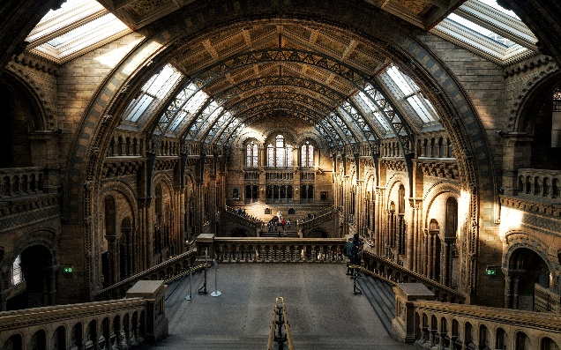 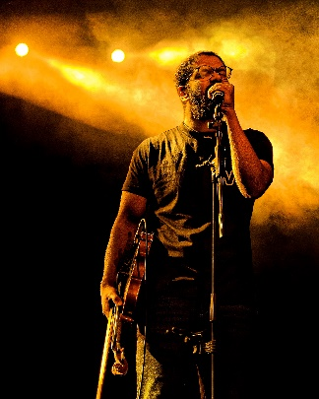 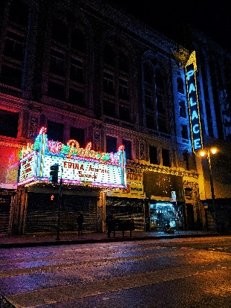  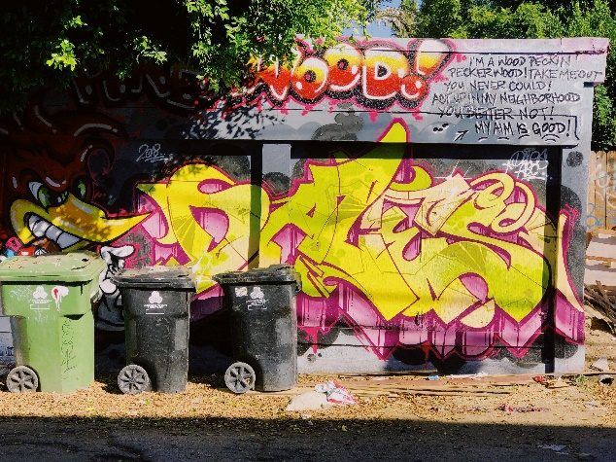

Example layouts:

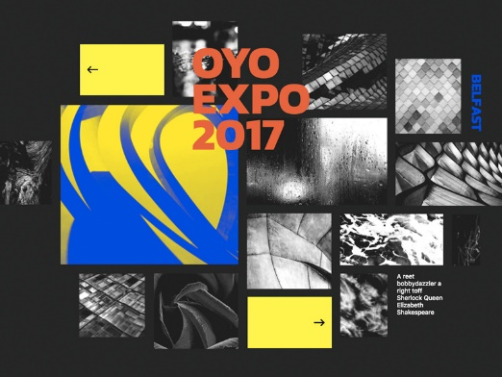 (example of how the home page should look)

(Example of navigation and music page) <https://www.broadway.org/tours>

Tour page example: <https://www.broadway.org/tours/details/frozen,979>

(Usability): <https://broadwaymusicalhome.com/people.htm>

Event: AUG 1, 2020

CARAMOOR FESTIVAL

KATONAH, NY

**Caramoor Music Festival announces cancellation of 2020 event**

<https://www.cincinnati.com/story/entertainment/2020/06/15/bellwether-music-festival-cancelled-covid-coronavirus-cincinnati/3191476001/>

The Caramoorr Music Festival announced the 2020 event's cancellation Monday. Organizers of the 3-day event cited conditions surrounding COVID-19 and current mandates from the state government as reasons for the cancellation.

"The safety and health of our guests, artists, partners, and staff are always our first priority," Bill Donabedian, co-founder of the festival, said in a press release.

The announcement comes after many other fairs and festivals across the state have made similar announcements. Others still are looking to keep their events alive in some way or another.